

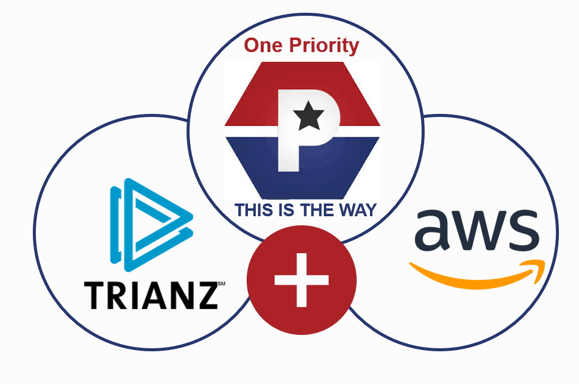

**June 2025**

**PW User Manual v8**

**TRIANZ CONFIDENTIAL**

**trianz.com**

**Table of Contents**

Introduction 2

Purpose of Documentation 2

Scope and Audience 2

Overview 2

High-Level Architecture 2

Core Components 2

EKS Control Plane (Managed by AWS) 2

Worker Nodes (EC2 or Fargate) 3

Networking & Security 3

Resiliency & High Availability 3

Multi-AZ Resilience 3

Autoscaling Strategies 3

Failure Recovery 3

Microservices Deployment Model 3

Service Communication 3

Workload Orchestration 3

Observability: Logging & Monitoring 4

Logging 4

Metrics 4

Alerting & Incident Management 4

Security Best Practices 4

IAM & RBAC 4

Network Security 4

Data Protection 4

Conclusion 4

# Introduction

## Purpose of Documentation

This document provides a high-level overview of the **Amazon Elastic Kubernetes Service (EKS) architecture**, focusing on **resiliency, scalability, microservices deployment, and observability**.

## Scope and Audience

The documentation is intended to provide a comprehensive guide for the EKS configurations across multiple environments.

This document is intended for the following roles:

1. **Clients & Stakeholders** – Understanding the cloud-native architecture.
2. **DevOps & Infrastructure Teams** – Managing and optimizing EKS deployments.
3. **Developers** – Deploying and maintaining microservices efficiently.

# Overview

This documentation provides an overview of the configurations, resources, and operational details of the existing Amazon Elastic Kubernetes Service (EKS) clusters in use across various environments (Development and UAT). It serves as a reference for understanding the cluster configurations, ensuring consistency across environments.

The EKS cluster is configured to support containerized workloads with automatic scaling, secure networking, and centralized logging and monitoring. This document outlines the architecture with key configurations.

# High-Level Architecture

Amazon EKS is a managed Kubernetes service designed to run and scale containerized applications across **multiple Availability Zones (AZs)**. The cluster consists of:

## Core Components

### EKS Control Plane (Managed by AWS)

* API Server, Scheduler, etcd, and Controller Manager.
* Automatically distributed across multiple AZs for **high availability**.

### Worker Nodes (EC2)

* Managed Node Groups with instance types: t3.medium and t3.large.
* Karpenter Autoscaler optimizes node provisioning dynamically.

### ****Networking**** & Security

* **Amazon VPC CNI** for pod networking.
* **VPC** with private/public subnets to ensure secure networking.
* **Network Policies & Security Groups** for traffic control.

## Resiliency & High Availability

EKS is designed for fault tolerance and ensures **high availability** through:

## Multi-AZ Resilience

* Control Plane is **automatically replicated** across AZs.
* Worker nodes must be **distributed across AZs** for redundancy.

## ****Autoscaling Strategies****

* **Managed Node Group** – Adjusts node groups based on pending workloads.
* **Karpenter** – Provisions on-demand capacity with optimized instance selection.

### FailureRecovery

* **Pod Disruptions** – Kubernetes reschedules failed pods automatically.
* **Node Failures** – Auto-healing via Karpenter/Auto Scaling Groups.

## Microservices Deployment Model

EKS is ideal for **microservices-based applications** due to its flexibility and scalability. Key components include:

## Service Communication

* **Ingress Controller: ALB** with **HTTPS** termination.
* **Internal Load Balancing** – Services communicate within the cluster via ClusterIP.

## ****Workload Orchestration****

* **Helm** based deployments for managing microservices.

# ****Observability: Logging & Monitoring****

Monitoring and logging are crucial for **troubleshooting and performance optimization**.

## Logging

* **Amazon CloudWatch & Fluent Bit** – Captures logs for:
  + EKS Control Plane (API server, scheduler, etc.).
  + Application workloads.

## ****Metrics****

* **CloudWatch Container Insights** – Collects cluster and workload metrics.

## ****Alerting & Incident Management****

* **AWS Security Hub & GuardDuty** – Monitors for security threats.
* **CloudWatch Alarms & SNS** – Sends alerts based on threshold breaches.(Need to configure)

# ****Security Best Practices****

Security in EKS is **multi-layered**, involving:

## IAM & RBAC

* **AWS IAM Roles for Service Accounts (IRSA)** – Implemented for fine-grained permissions.
* **Kubernetes RBAC** configured with **least privilege** policies.

## ****Network Security****

* **Private API Endpoints** – Restricting access to the control plane.
* **Network Policies** – Restricting inter-service communication.

## ****Data Protection****

* **EBS Volume Encryption** – Ensures data security and **enabled** using AWS KMS.
* **KMS Encryption for Secrets** **in use** to secure application credentials.

# ****Conclusion****

The current Amazon EKS configuration provides a **resilient, scalable, and secure** platform for running modern microservices applications. By leveraging **multi-AZ deployments, autoscaling mechanisms, observability tools, and security best practices**, organizations can ensure **high availability and operational efficiency.**

The content in this document is copyrighted; any unauthorized use – in part or full – may violate the copyright, trademark, and other laws. This document may not be modified, reproduced or publicly displayed, performed or distributed, or used for any public or commercial purposes. The Trianz name and its products are subject to trademark and copyright protections, regardless of how and where referenced.



reach@trianz.com

**Thank You**

**  **

**Contact Information**

Ramya Amaravadhi

ramya.amaravadhi@trianz.com

reach@trianz.com

**Thank You**

The content in this document is copyrighted; any unauthorized use – in part or full – may violate the copyright, trademark, and other laws. This document may not be modified, reproduced or publicly displayed, performed or distributed, or used for any public or commercial purposes. The Trianz name and its products are subject to trademark and copyright protections, regardless of how and where referenced.

**Contact Information**

Name

Email

Phone